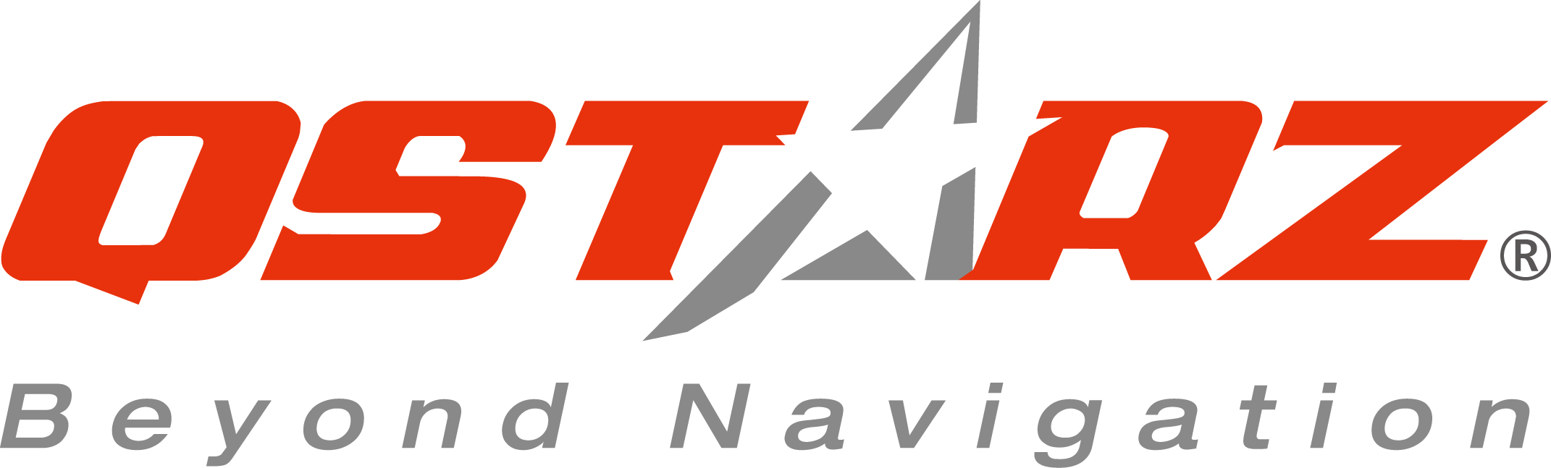
Application Form



Please fill out the form and send it to Blaire Hou (Blaire_Hou@qstarz.com)

Name
Nationality
Age
Team Name or Organization Name
The number of team members
Vehicle Type
Latest racing results and ranking
The leveexposure for this event you can provide, such as blogs or websites.
Please list.

